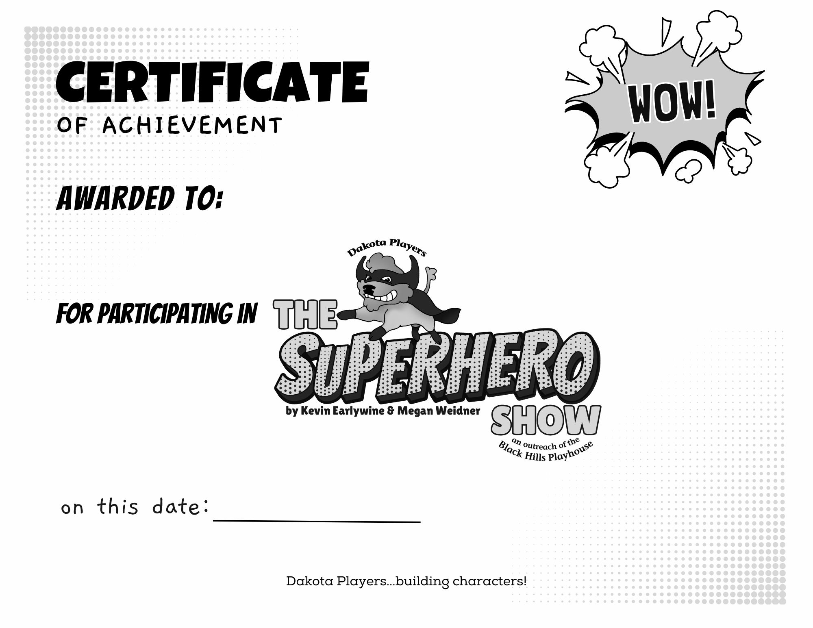
{double click to insert Name}
{double click Date}

