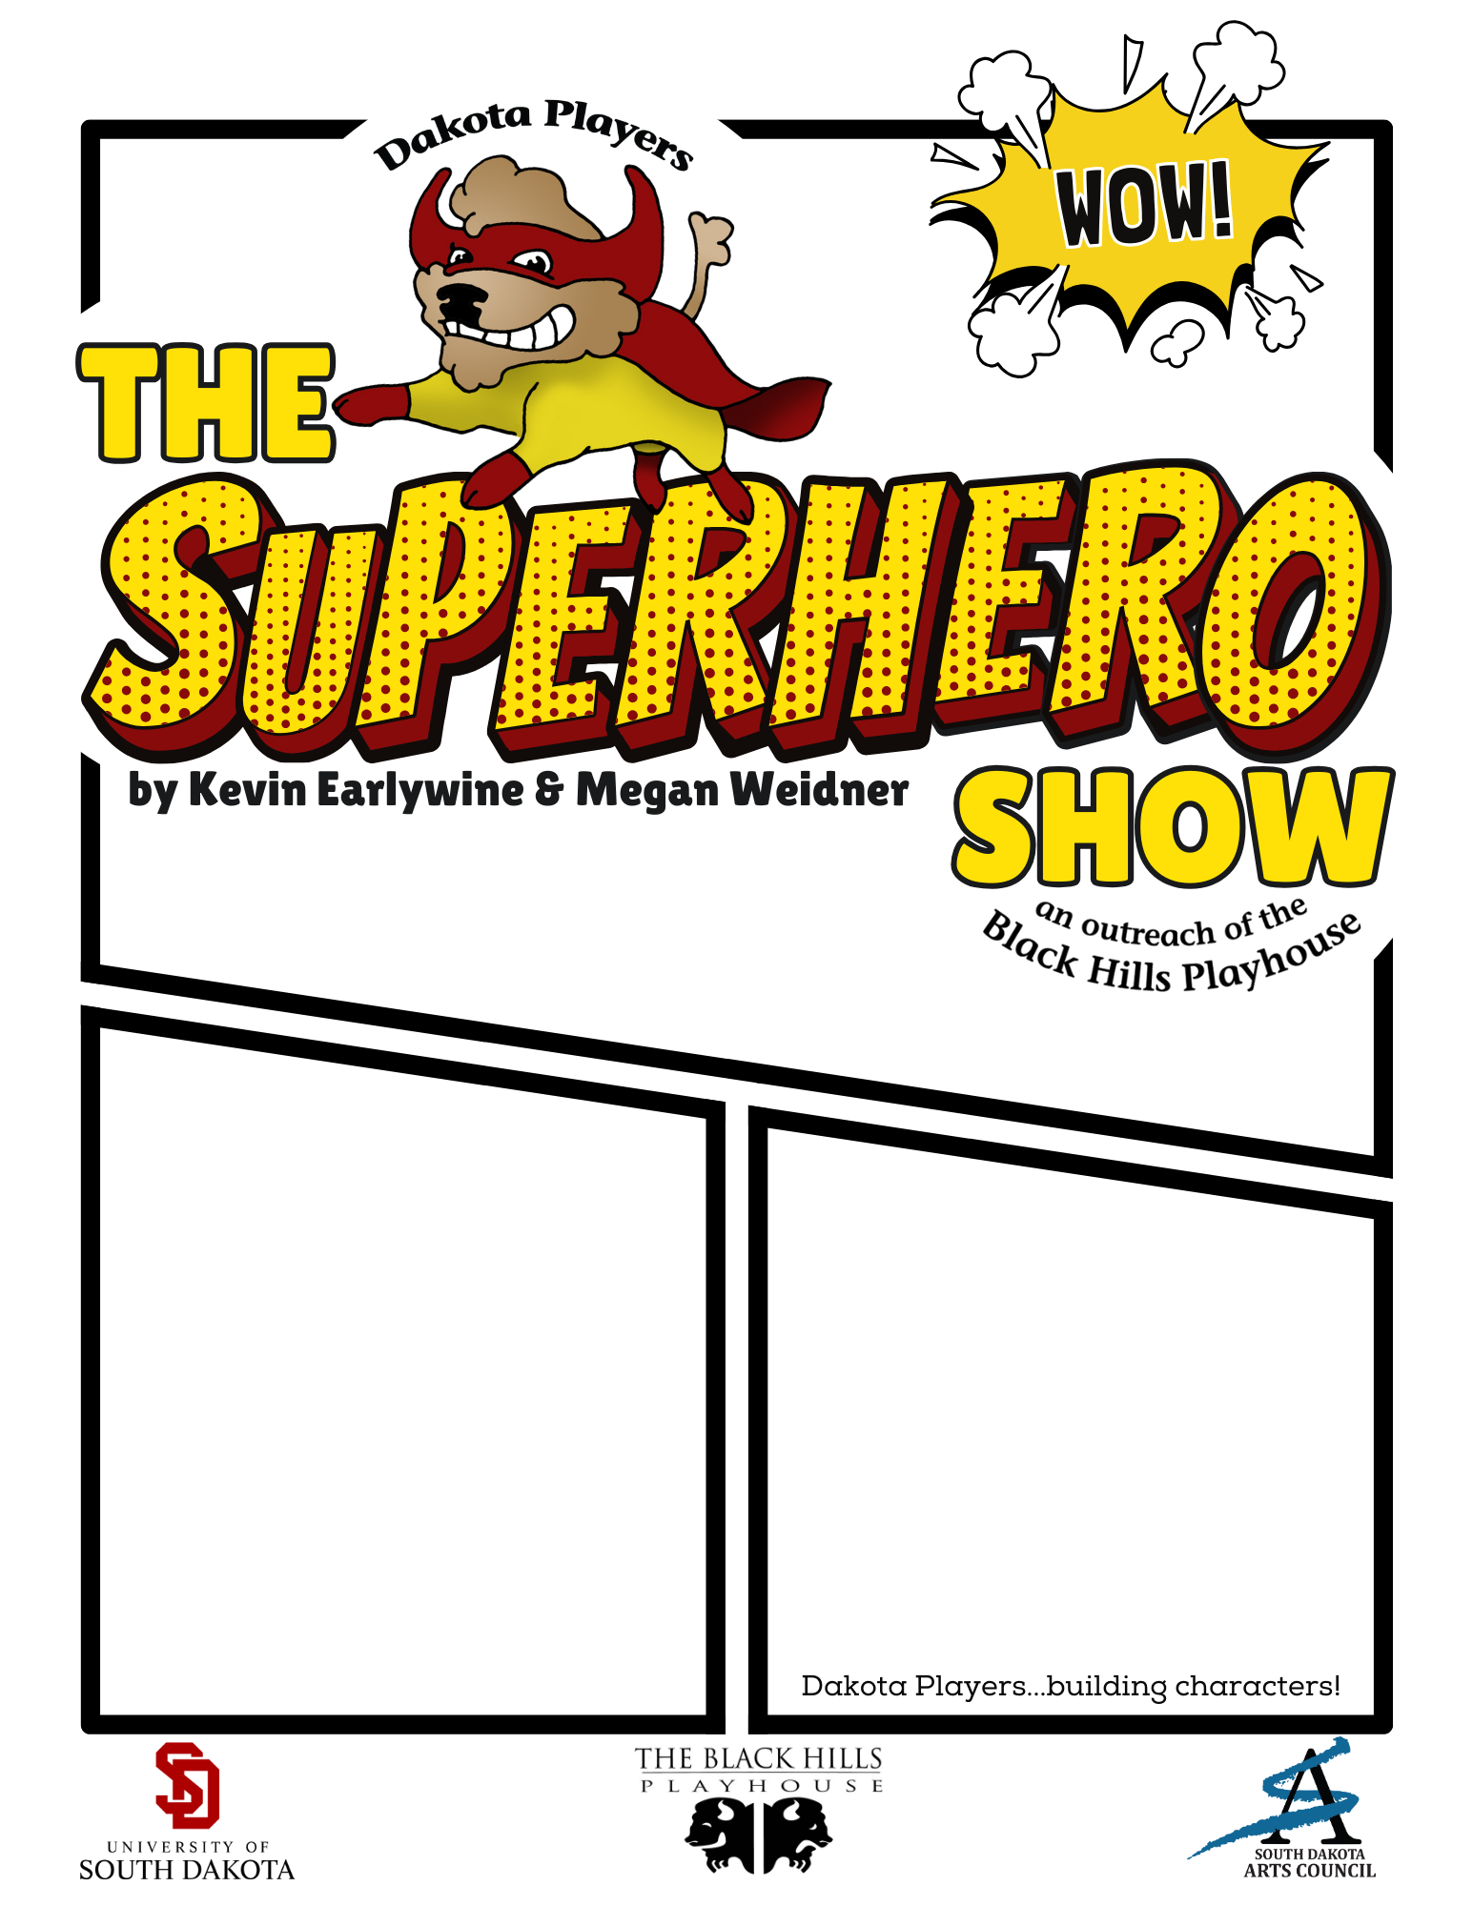
{Insert Performance Location/Instructions Here}
{Insert Performance Date & Time / Admission Price}

