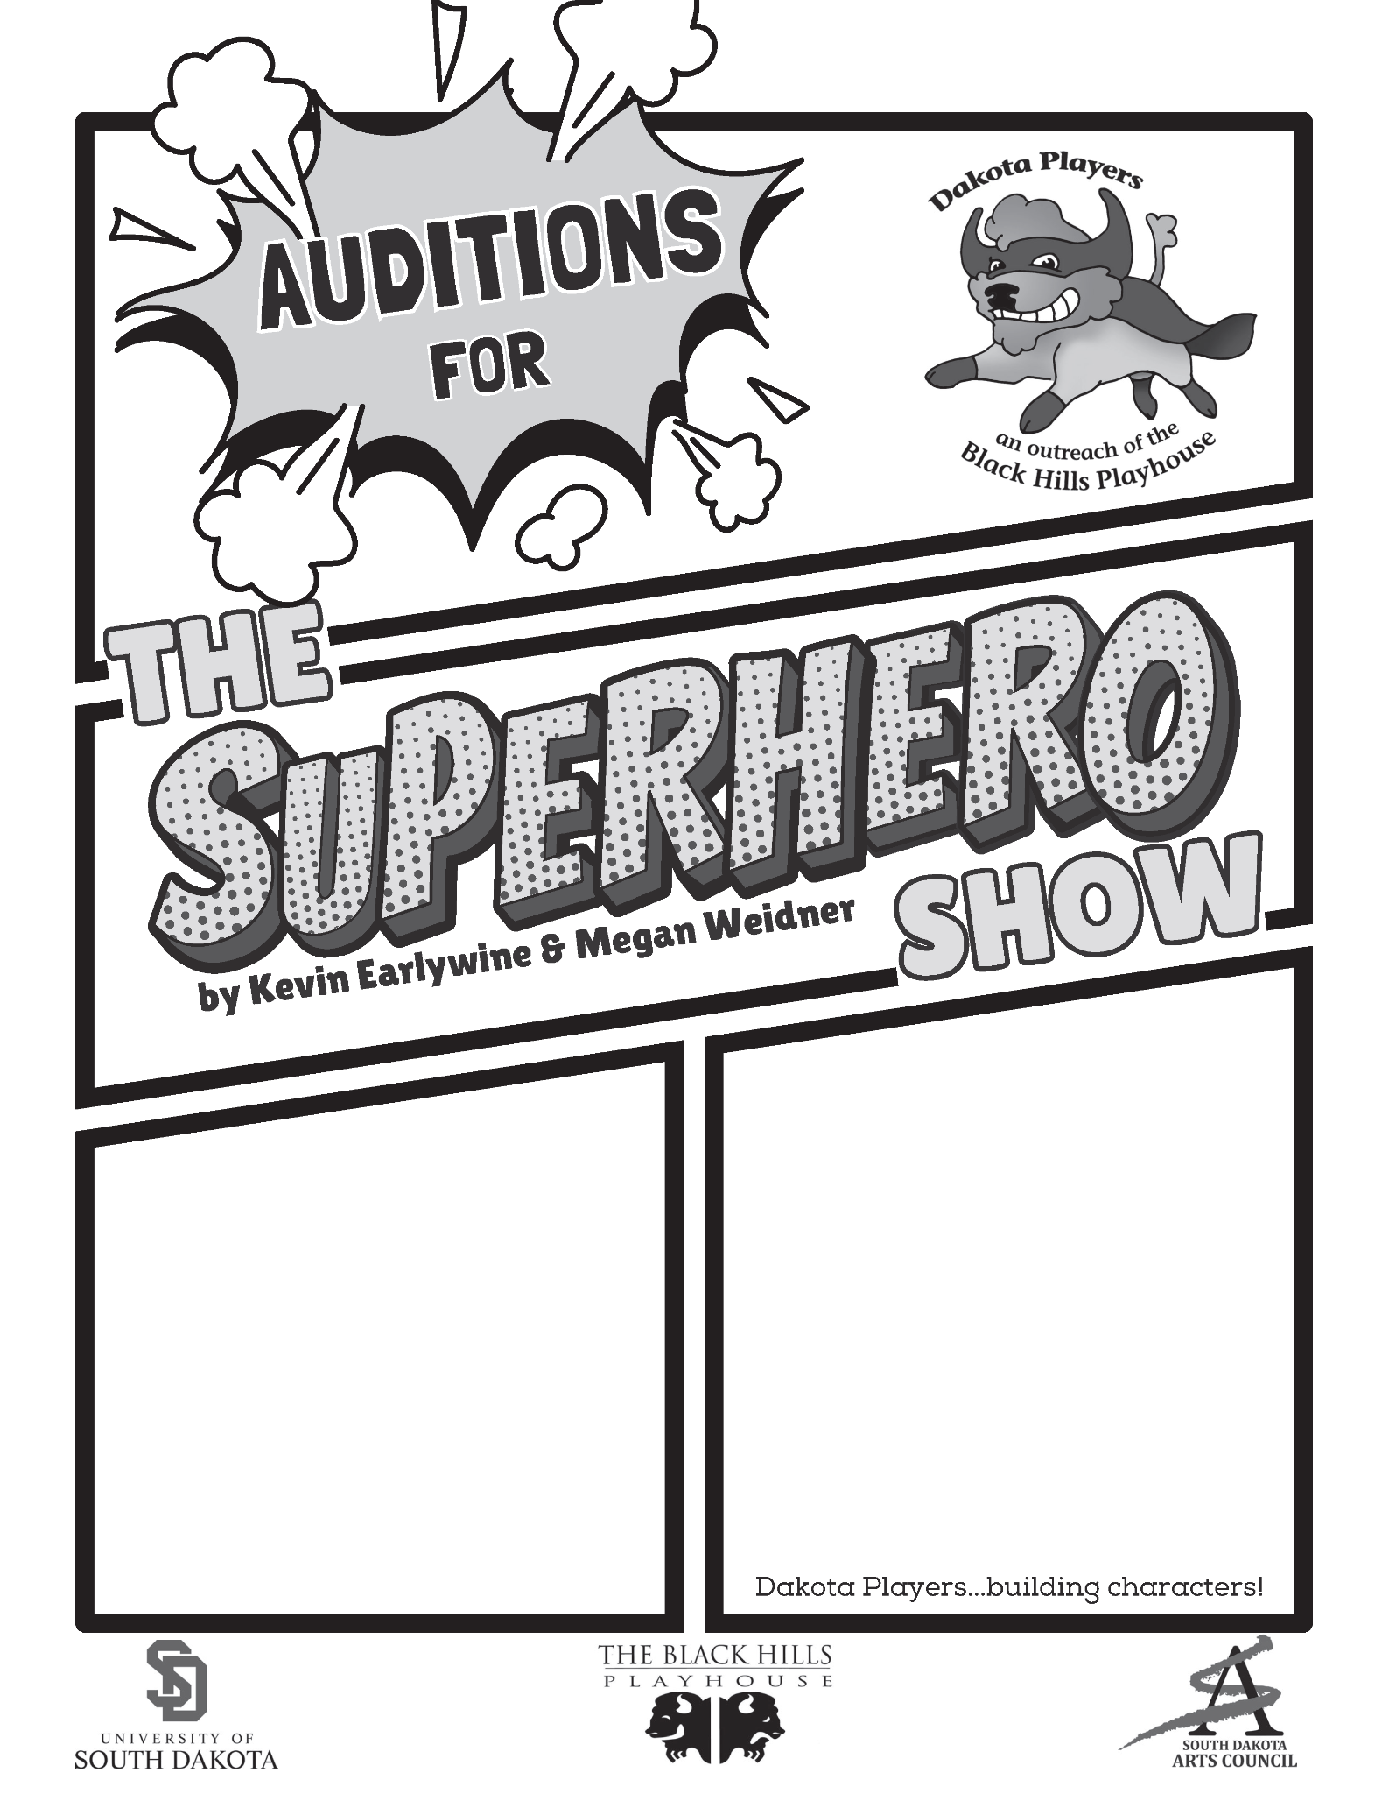
{Insert Audition Location/Instructions Here}
{Insert Audition Date & Time}

